Design and Implementation of VyntraMart Site for Online Shopping

# ABSTRACT

In today’s fast-changing business environment, it’s extremely important to be able to respond to client needs in the most effective and timely manner. If your customers wish to see your business online and have instant access to your products or services.

Online Shopping is a lifestyle VyntraMart application, which retails various fashion and lifestyle products. This project allows viewing various products available enables registered users to purchase desired products instantly using PayPal payment processor (Instant Pay) and also can place order by using Cash on Delivery (Pay Later) option. This project provides an easy access to Administrators and Managers to view orders placed using Pay Later and Instant Pay options.

In order to develop VyntraMart website, a number of Technologies must be studied and understood. These include multi-tiered architecture, server and client side scripting techniques, implementation technologies such as spring boot,angular,node.js, programming language (such as java ) and relational databases. This is a project with the objective to develop a basic website where a consumer is provided with a shopping cart application and also to know about the technologies used to develop such an application.

This document will discuss each of the underlying technologies to create and implement VyntraMart website.

## TABLE OF CONTENTS

*ABSTRACT 3*

*LIST OF FIGURES 6*

*1.0 INTRDUCTION 7*

* 1. *OVERALL DESCSRIPTION 7*
  2. *DESCRIPTION 7*
  3. *TECHNOLOGY STACK USED 8*
  4. *HIGH LEVEL ARCHITECTURE DIAGRAM 8*
  5. *SYSTEM REQUREMENT 9*
  6. *USE-CASE DIAGRAM 9*
  7. *ONLINE SHOPPING APPLICATION 9*

### *HOME PAGE*

* 1. ***ADMIN PAGE***
  2. ***REGISTER PAGE***
  3. ***LOGIN PAGE***
  4. ***SHOP PAGE***
  5. ***CART PAGE***
  6. ***SHIPPING ADDRESS PAGE***
  7. ***PAYMENT PAGE***
  8. ***TRACK ORDER***
  9. ***ABOUT US PAGE***
  10. ***DATA MANAGEMENT 16***
  11. ***DATA DESCRIPTION***
  12. ***DATA TABLE DIAGRAM AND RELATIONSHIPS***
  13. ***NON-FUNCTIONAL / OPERATIONAL REQUIREMENTS 19***
  14. ***SECURITY***
  15. ***EFFICIENCY AND MAINTAINABLITY***

**1.0 INTRODUCTION:**

E-commerce is fast gaining ground as an accepted and used business paradigm. More and more business houses are implementing web sites providing functionality for performing commercial transactions over the web. It is reasonable to say that the process of shopping on the web is becoming commonplace.

The objective of this project is to develop a general purpose e-commerce store where product like clothes can be bought from the comfort of home through the Internet. However, for implementation purposes, this paper will deal with an online shopping for clothes.

An online store is a virtual store on the Internet where customers can browse the catalog and select products of interest. The selected items may be collected in a shopping cart. At checkout time, the items in the shopping cart will be presented as an order. At that time, more information will be needed to complete the transaction. Usually, the customer will be asked to fill or select a billing address, a shipping address, a shipping option, and payment information such as credit card number.

## OVERALL DESCRIPTION:

### Description:

* + - Any member can register and view available products.
    - Only registered member can purchase multiple products regardless of quantity.
    - There are three roles available: Visitor, User and Admin.
      * Visitor can view available products.
      * User can view and purchase products.
      * An Admin has some extra privilege including all privilege of visitor and user.
        + Admin can add products, edit product information and add/remove product.
        + Admin can add user, edit user information and can remove user.

### Technology Stack Used:

1. **Front-End Presentation Layer:** HTML5,TS using Angular framework on Node.js
2. **Back-End Server Side Implementation:** Java ,Spring boot, Spring Rest Controller, Spring Security & Hibernate
3. **Database:** MySql controlled by hibernate.

### 

### High Level Architecture Diagram:

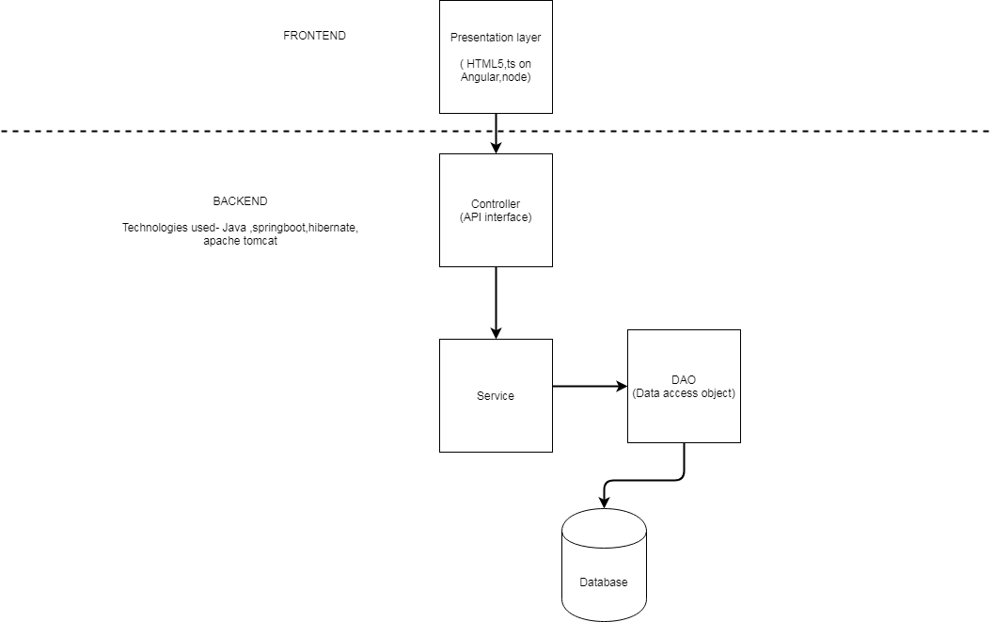

* 1. **SYSTEM REQUREMENTS:**

### USE-CASE DIAGRAM:

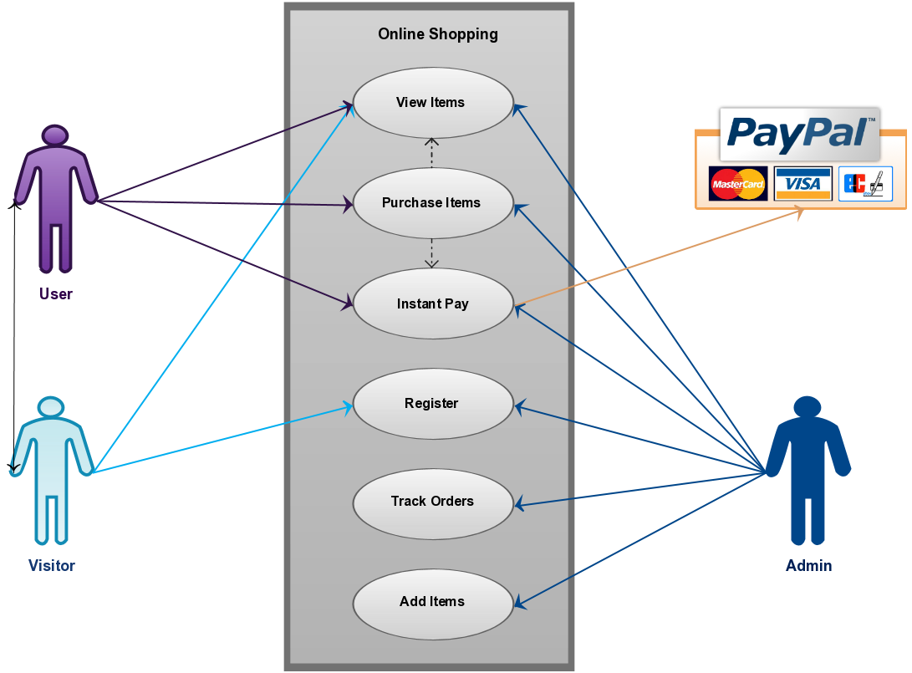

* 1. **ONLINE SHOPPING APPLICATION:**

Anyone can view Online Shopping portal and available products, but every user must login by his/her Username and password in order to purchase or order products. Unregistered members can register by navigating to registration page. Only Admin will have access to modify roles, by default developer can only be an ‘Admin’. Once user register site, his default role will be ‘User’.

* 1. **HOMEPAGE:** The Home Screen will consist of screen where one can browse through the products which we have on our website.



* 1. **Admin Login Page:** This login page is especially designed for administrator login only. After successfully login with admin credentials, the admin will get page to add new products or delete already added products. And only admin has the authorization to add new products.

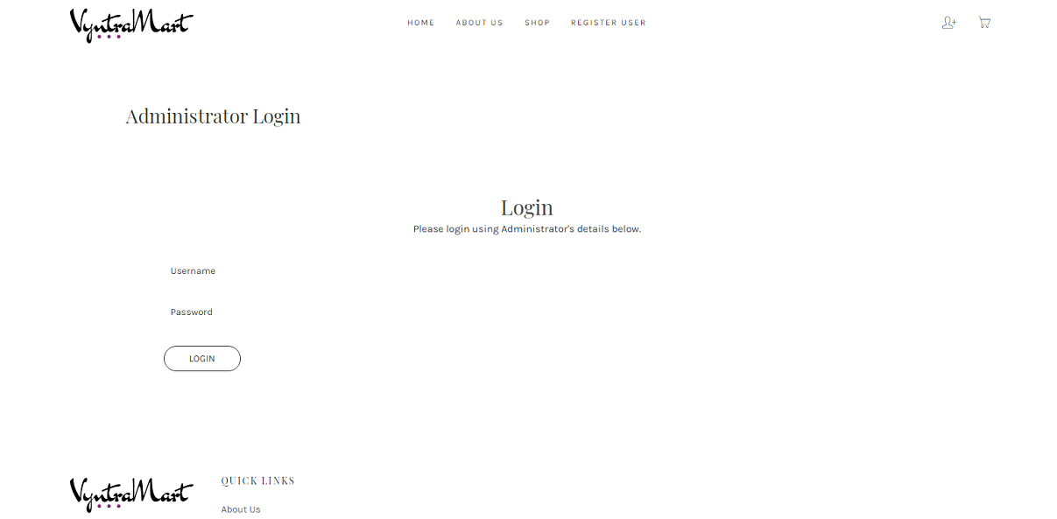

* + 1. **Add Product Page :**

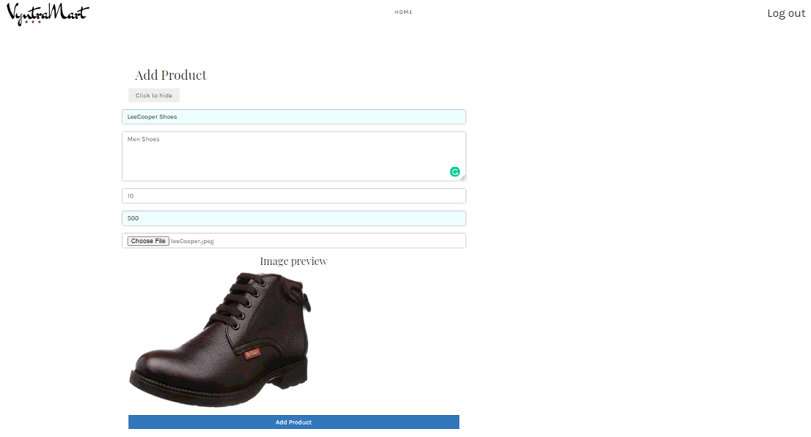

* + 1. **Delete Added Product Page:**

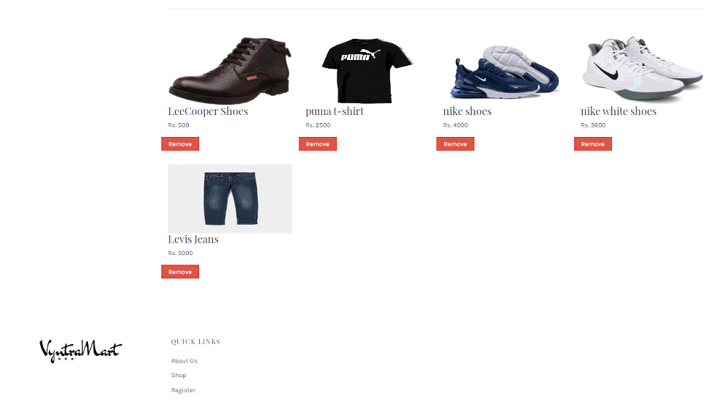

* 1. **REGISTER PAGE:** New users can register on this page.

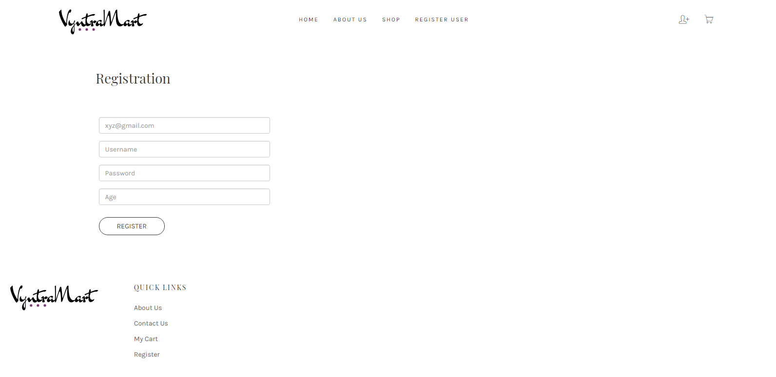

* 1. **LOGIN PAGE:** Login page for both users and administrators.

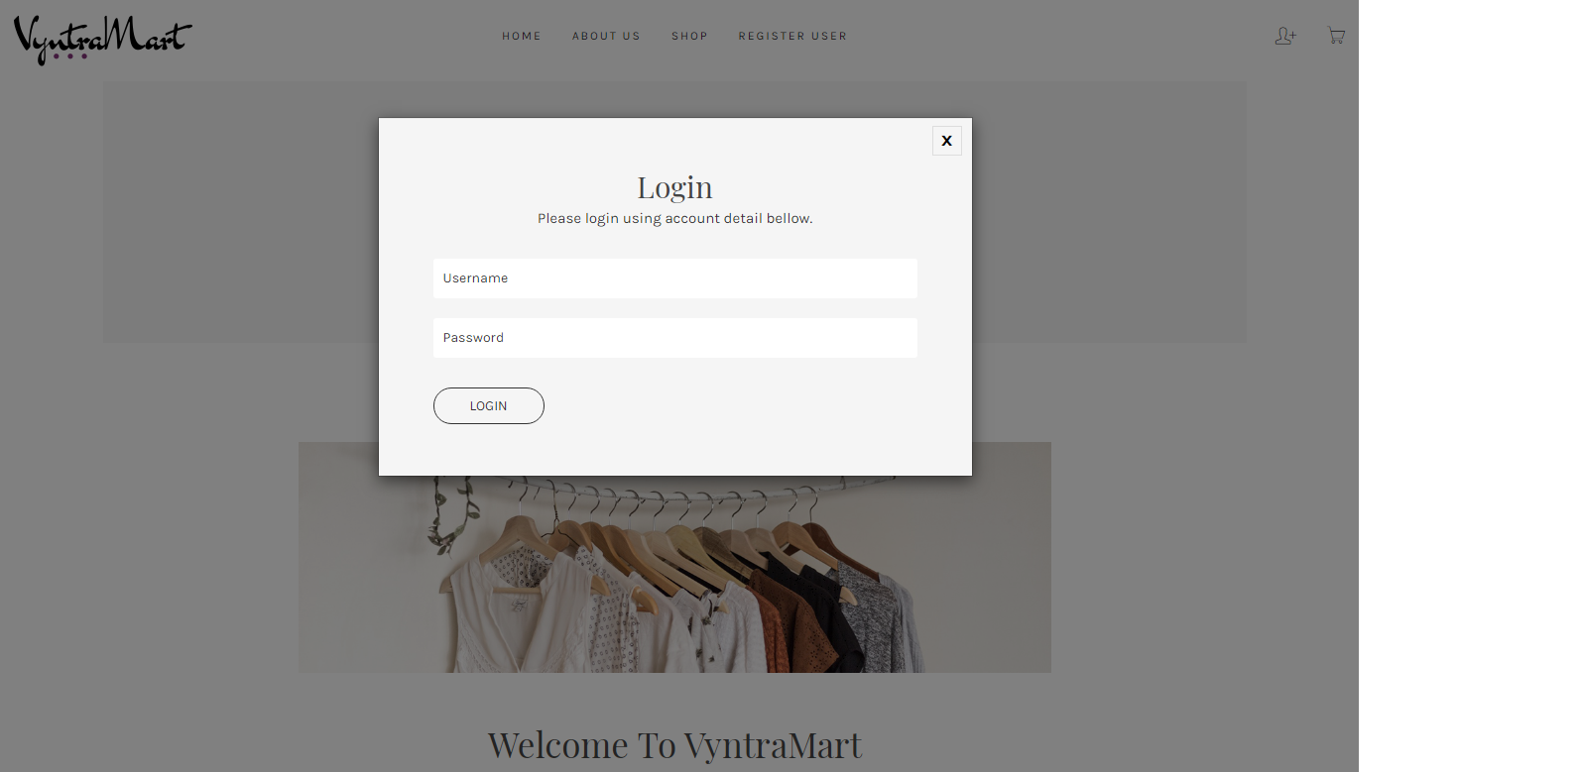

* 1. **Shop Page:** Registered users can order desired products from here.

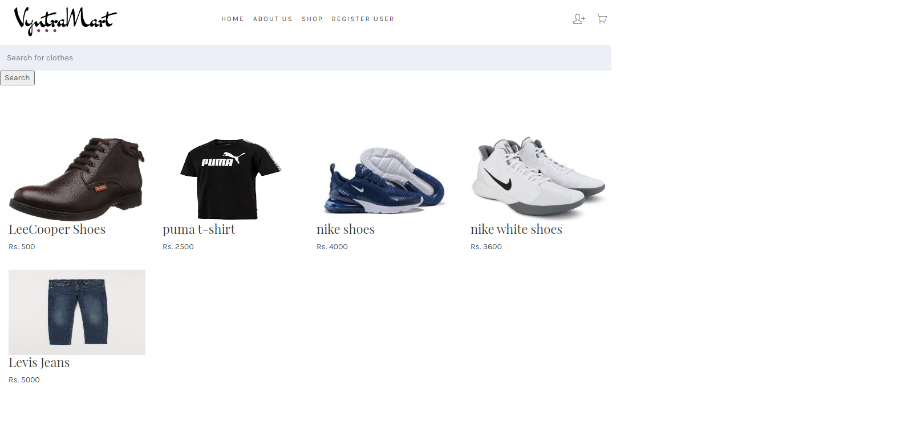

* 1. **Cart Page:** Once users order item they are able to see ordered products and grand total.

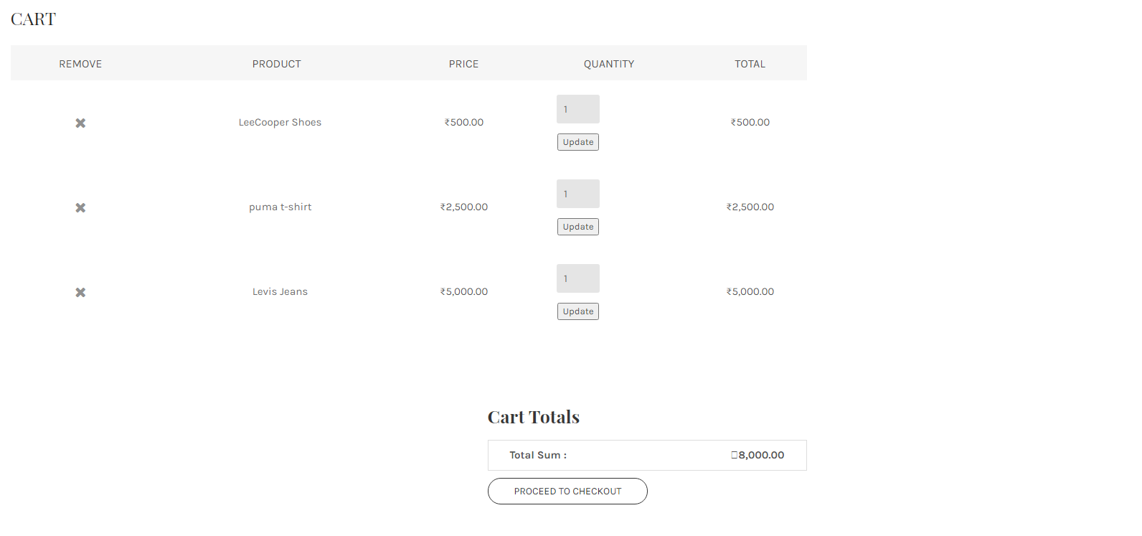

* 1. **Shipping Address Page:**

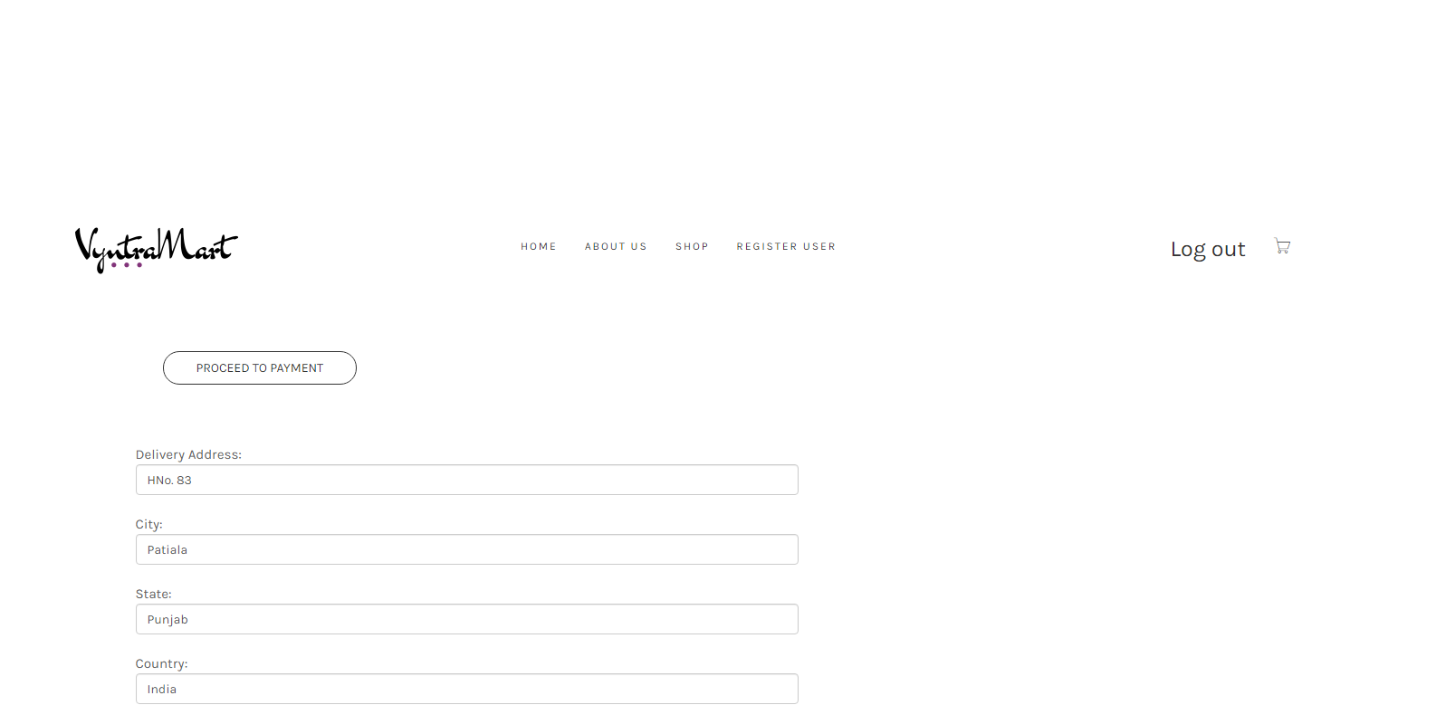

* 1. **Payment Page:**

Once users orders products they are redirected to payment page.

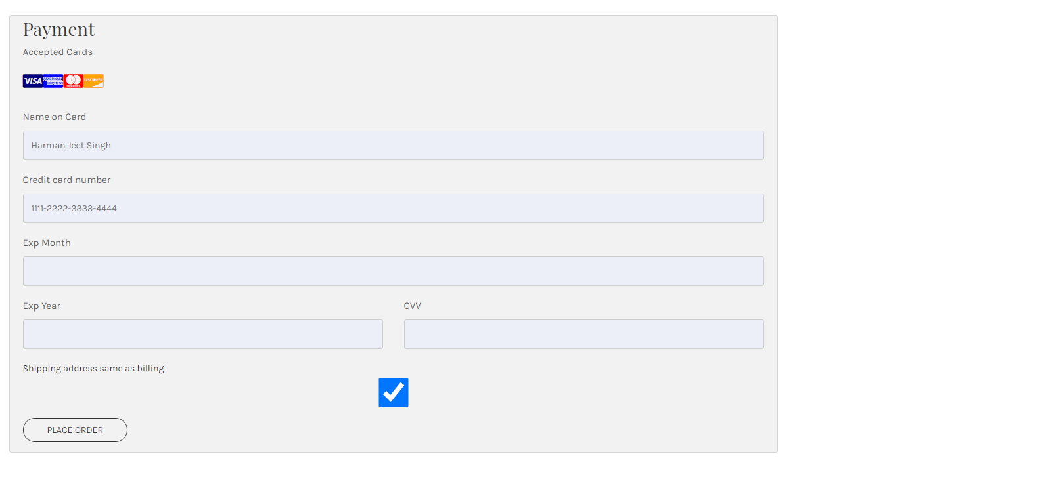

* 1. **Track order:** Website Administrators can track and ship orders here.

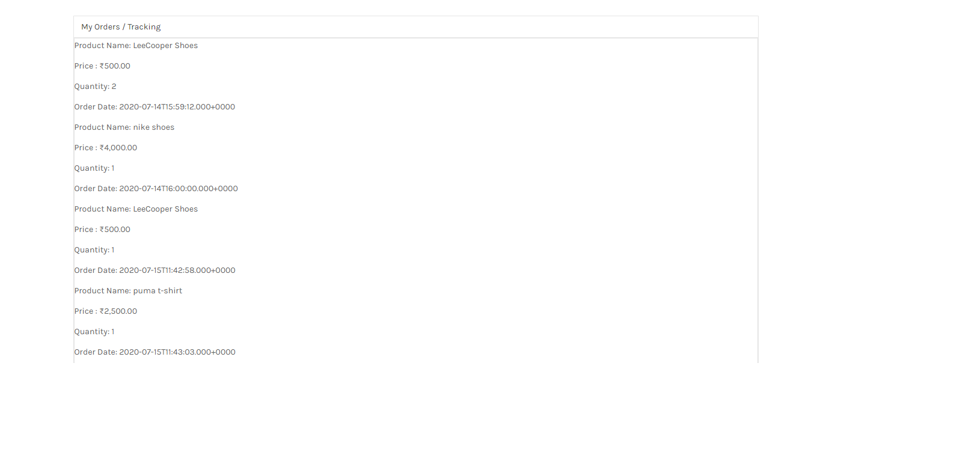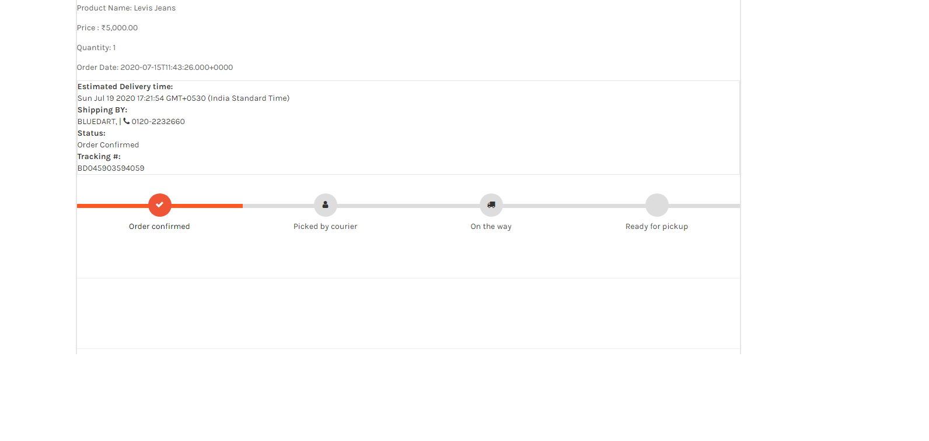

* 1. **About Us Page:** This page describes about website and owners

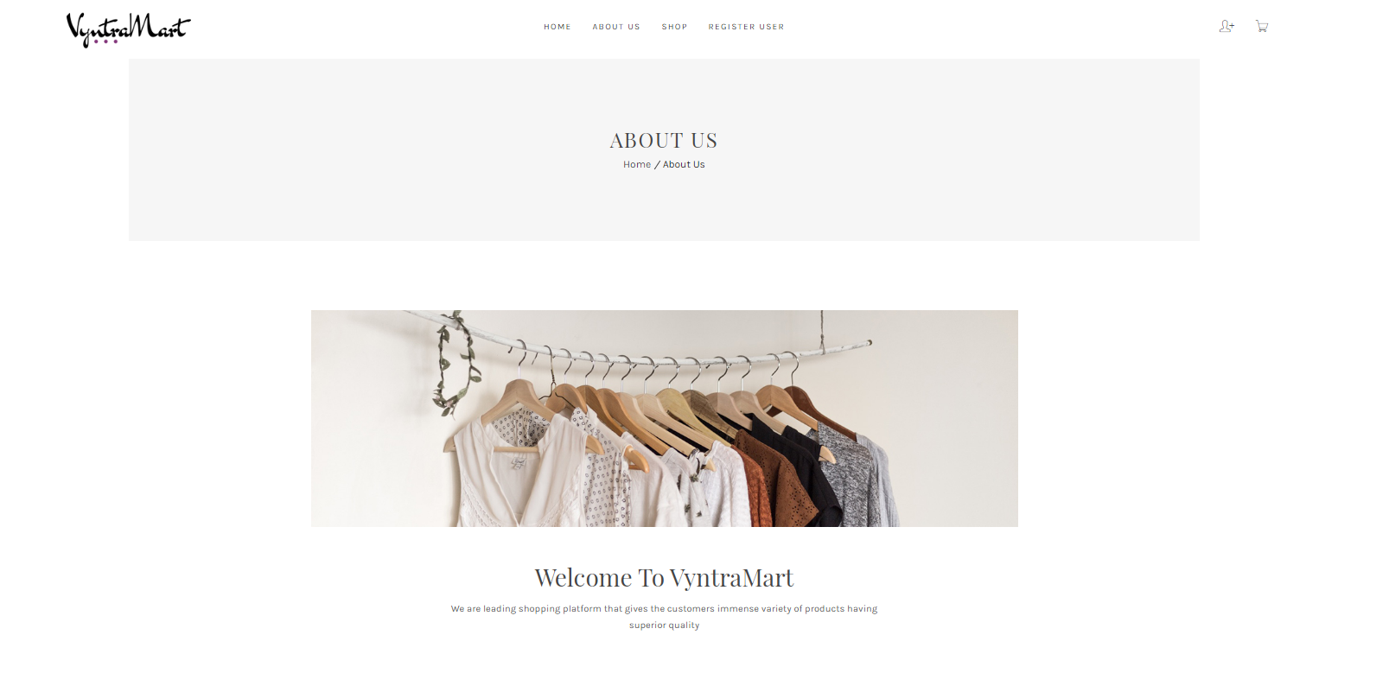

* 1. **Data Management**
  2. **Data Description**

This database consists of

* + - Users: User and Admin information is added to database with Unique ID based on their roles.
    - Products: Complete products information is stored in this table.
    - Cart: Customer ordered products, status and delivery information is stored in this table.
    - User Address: The shipping address of the user is stored in this table.

* 1. **Database Table Diagram and Relationships**

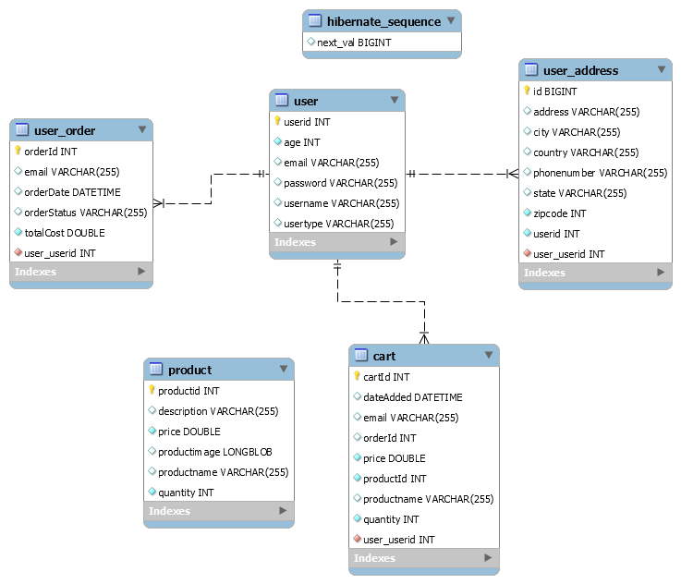

* 1. **Non-Functional / Operational Requirements**
  2. **Security**
     + Pages of the website must be access in the way they were intended to be accessed.

Included files shall not be accessed outside of their parent file.

* + - Administrator can only perform administrative task on pages they are privileged to access. Customers will not be allowed to access the administrator pages.

### Efficiency and Maintainability

* + - Page loads should be returned and formatted in a timely fashion depending on the request being made.
    - Administrators will have the ability to edit the aspects of the order forms, product descriptions, prices and website directly